LINKED LIST

- Given the head of a singly linked list, return the middle node of the linked list. If there are two middle nodes, return the second middle node.



Solution:

public ListNode middleNode(ListNode head) {
ListNode slow = head, fast = head;
while (fast!=null && fast.next != null) {
fast = fast.next.next;
slow = slow.next;
}
return slow;
}
TC: O(n) where n is the nodes in the linked list.

- Given the heads of two singly linked-lists headA and headB, return the node at which the two lists intersect. If the two linked lists have no intersection at all, return null.

For example, the following two linked lists begin to intersect at node c1:

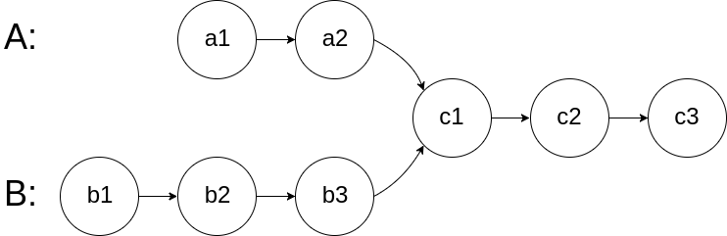

Solution:

public ListNode getIntersectionNode(ListNode headA, ListNode headB) {
int lenA = 0, lenB = 0;
ListNode currA = headA, currB = headB;
while(currA != null) {
lenA++;
currA = currA.next;
}
while(currB != null) {
lenB++;
currB = currB.next;
}
currA = headA;
currB = headB;
if(lenA > lenB) {
for(int i=0; i<lenA-lenB; i++)
currA = currA.next;
} else {
for(int i=0; i<lenB-lenA; i++)
currB = currB.next;
}
while(currA!= currB) {
currA = currA.next;
currB = currB.next;
}
return currA;
}

TC: O(max(m,n) where m,n is the no of nodes in L.L A,B respectively.
SC: O(1)

- Given the head of a singly linked list, reverse the list, and return the reversed list.

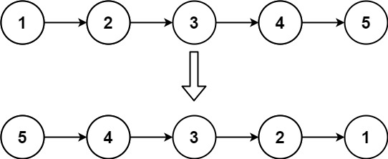

Solution:

public ListNode reverseList(ListNode head) {
ListNode prev = null;
ListNode current = head;

while(current != null) {
ListNode next = current.next;
current.next = prev;
prev = current;
current = next;
}
return prev;
}

TC: O(n) where n is the no of nodes in the list.

- Remove duplicate elements from sorted linked list.
For example, if the given linked list is 1->2->2->2->5->6 then the output should be 1->2->5->6.

Solution:
public void removeDuplicates(Node head) {
if (head == null) {
return;
}

Node prev = head;
Node current = head.next;

while (current != null) {
if (current.data == prev.data) {
prev.next = current.next;
current = current.next;
} else {
prev = current;
current = current.next;
}
}
}

TC: O(n)
SC: O(1)
- Clone a linked list with next and random pointer.
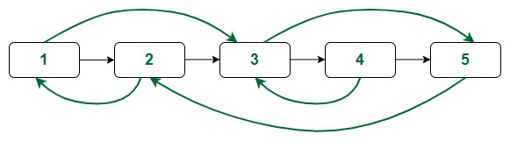
Solution:
// A linked list node with a random pointer
class Node
{
int data;
Node next, random;

// Constructor
Node(int data) {
this.data = data;
}
}

class Main
{
// Recursive function to print a linked list
public static void traverse(Node head)
{
// traverse the linked list
while (head != null)
{
// print current node data and random pointer data
if (head.random != null) {
System.out.print(head.data + "(" + head.random.data + ") —> ");
}
else {
System.out.print(head.data + "(" + "X" + ") —> ");
}

// advance to the next node
head = head.next;
}

System.out.println("null");
}

// Function to clone a linked list having random pointers
public static Node cloneLinkedList(Node head)
{
/* 1. Create a duplicate of each node of the original linked list */

// traverse the original linked list
Node curr = head;
while (curr != null)
{
// take a pointer to the next node in the original list
Node next = curr.next;

// duplicate each node of the linked list
Node dup = new Node(curr.data);

// associate each duplicate node with the next child of the original node
curr.next = dup;
dup.next = next;

// advance to the next node in the original list
curr = next;
}

/* 2. Update the random pointers of the duplicated nodes */

// traverse the modified list
curr = head;
while (curr != null)
{
// if a random pointer for the original node exists, set it for the clone
if (curr.random != null) {
(curr.next).random = (curr.random).next;
}

// advance to the next node in the original list
curr = (curr.next).next;
}

/* 3. Extract the duplicate nodes from the modified list */

// construct a dummy node whose next pointer points to the head
// of the cloned linked list
Node dummy = new Node(-1);

// maintain a tail node for the clone
Node tail = dummy;

// traverse the modified list
curr = head;
while (curr != null)
{
// take a pointer to the next node in the original list
Node next = curr.next.next;

// extract the duplicate
Node dup = curr.next;
tail.next = dup;
tail = dup;

// restore the original linked list
curr.next = next;

// advance to the next node in the original list
curr = next;
}

// return head node of the cloned list
return dummy.next;
}

public static void main(String[] args)
{
Node head = new Node(1);
head.next = new Node(2);
head.next.next = new Node(3);
head.next.next.next = new Node(4);
head.next.next.next.next = new Node(5);

head.random = head.next.next.next;
head.next.next.random = head.next;

System.out.print("Original linked list:\n");
traverse(head);

Node clone = cloneLinkedList(head);

System.out.print("\nCloned linked list:\n");
traverse(clone);
}
}

TC: O(n)
SC: O(1)

